# HUALAOWEI

SMART CITY PROPOSAL

TRACK 2: Improve Citizen Engagement and Civic Services

This proposal envisions a future where Artificial Intelligence, Cloud Computing, and Intelligent Systems work hand in hand to transform urban living, paving the way for a smarter, more connected Singapore.



Woo Yan Seun





Tang Ming Feng



Jerick Cheong



Fleming Siow









# **INTRODUCTION**

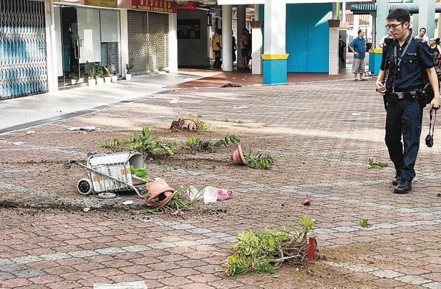

|  |  |
| --- | --- |
|  | OneService |
| **Problem Statement**  As one of the world’s most densely populated cities, SG faces growing urban management challenges. Conventional issue-reporting methods often result in delayed responses and a lack of proactive measures. With rising demands for public services, real-time responsiveness and predictive insights are critical to maintaining efficiency and sustainability. | The OneService app, developed by the SG government, provides a centralised platform for citizens to report municipal issues. It also features a chatbot for answering queries and routing reports to relevant agencies. While it has greatly streamlined issue reporting, it has notable limitations, such as a lack of **advanced** issue detection, **online** social engagement, and **predictive analysis** for proactive planning. |

|  |  |
| --- | --- |
| **Open Source Services** | While SG does not have readily available municipal data, such issues are **prevalent across the world**, and we can make use of data gathered by **global municipal open data initiatives**, **urban research projects** etc. for **insights** and **AI training**. This method can ensure a localised yet **data-driven approach** to improving civic services in SG. |

|  |
| --- |
| Open311  Open311 is an **open standard** for civic issue reporting, enabling structured data exchange between citizens, municipalities, and third-party applications. While not adopted by SG's agencies, we can leverage its **standardised format** to improve AI model training, enhance issue classification, and strengthen predictive analytics. Using Open311-compatible data ensures scalability, interoperability, and alignment with global smart city frameworks, while datasets from other cities help refine AI-driven issue detection and prioritisation. |
| Crowdsourced Data  The internet has a compilation of crowdsourced civic issue reports, capturing real-world citizen feedback on urban problems such as road damage, waste management, and faulty infrastructure. It provides valuable insights into how residents engage with local governments, report issues, and track resolution progress. An example would be **FixMyStreet**, which provides a wealth of **crowdsourced civic issue reports**, widely used in model training (e.g., **OpenPotBot** [[Link](https://github.com/OpenPotBot/FixMyStreetDataset)]) for classifying and enriching street fault data. |
| OpenStreetMap  OpenStreetMap (OSM) is a collaborative, **open-source mapping platform** that provides detailed geographic data, including street networks, public amenities, and infrastructure layouts. Unlike proprietary mapping services, OSM allows full data access and customisation, making it ideal for AI-powered issue detection and predictive analytics.  With OSM, we can accurately geotag reported issues without the use of paid services,  and also overlay reports to enhance spatial analysis for smarter municipal planning. |

|  |  |
| --- | --- |
| **Expected Impact**  Through our findings, we believe that by leveraging global open data initiatives and crowdsourced insights, we can harness the power of AI and Cloud Computing to drive more efficient civic engagement, and enhanced municipal services, thus achieving the following: | stopwatch-20Improved Response Time  AI-driven categorisation and prioritisation, allows issues to be rectified earlier. |
| people-carryIncreased Citizen Participation  Social engagement and transparent issue tracking. |
| cityProactive Urban Planning  Data-driven insights to predict and prevent recurring issues. |

# **OUR SOLUTION**

|  |  |  |  |  |  |  |
| --- | --- | --- | --- | --- | --- | --- |
| **Core Features**  Our solution is a mobile application that consists of several user-centric thought designs which utilises Cloud Computing and Smart City AI technologies to enhance the issue-reporting experience. | tablet-alt | | **Municipal Reporting App** | user-circle | | **Public Forum** |
| ◼  ◼  map-marked-alt | Cross-platform app to report municipal  issues and track its status (STC. Reported, Acknowledged & Resolved) in real-time.  Authentication and authorisation  included for public security and identity. | | ◼  ◼ | Transparent community forum for  discussing reported issues, with personalised visibility & security options for users.  Like and commenting system, to drive  opinion and public engagement. | |
|  | | **Interactive Map** | exclamation-circle | | **Notification System** |
| ◼  ◼ | Displays open reported issues (along with user-submitted details), that were acknowledged by relevant authorities.  Allows filtering of displays by the report’s  category, severity, and status. | | ◼  ◼ | A real-time notification system to inform  users of any updates made to their  report status, or any issues near them.  Will be customisable per profile, and done via our app, and if feasible, SMS/WhatsApp. | |
| comment-dots | | **Personalised Assistant** | Eye with solid fill | | **Computer Vision Enhanced** |
| ◼  ◼ | **Multilingual**, session-based Large Language Model (LLM) Chatbot, w/ voice capabilities,  and Retrieval Augmented Generation (RAG).  Has the ability to guide users in municipal **queries**, submitting a report and provide real-time information on **live reports**. | | ◼  ◼ | Vision Language Model (VLM) to analyse multiple images or video submission to **categorise issue type** and **severity** level.  Geolocation metadata integrated to additionally assist in geotagging,  for a more automated reporting workflow. | |
| Statistics with solid fill | | **Predictive Analytics** | Ui Ux with solid fill | | **Analytical Dashboard** |
| ◼  ◼ | Deep Learning model(s) to **forecast** issue counts in a window period of **7 days**.  Done at a **region-based level** and crafted from a variety of sources such as **geospatial**, **socioeconomic**, **weather** & air quality data. | | ◼  ◼ | Plugin extension tool for any relevant  agencies to use for data analysis.  Features may include spatial navigating,  real-time monitoring of reported issues, visualisations and prioritisation etc. | |
| Upload with solid fill | | **Cloud Based Workflow** | puzzle-piece | | **Optional Features** (*If Feasible) |
| ◼  ◼ | Our system is designed to be fully cloud native, from frontend, to DB, to backend.  The design approach is to allow our solution to be accessible, scalable and reliable.  Details of this workflow is provided below. | | ◼  ◼ | Offline mode, so users may draft a report  even without internet connection.  Advanced CV model to access the fix's sustainability, by comparing before  and after images of the issue. | |

|  |  |  |  |
| --- | --- | --- | --- |
| **A** | **Connecting the Frontend to the Cloud** | | **Cloud Architecture** |
| ◼  ◼ | Our frontend will be hosted on Object Storage Service (OBS).  Any backend logic will be done via API calls to Huawei Cloud. | | How we integrate our features and technology into Huawei Cloud. |
|  |
| **B** | **API Routing for Our Services** | |
| ◼ | Requests from the app are handled and routed via API Gateway to: | |  |
|  | **i** | **OBS for Media Storage** |
|  | ■ | Object Storage Service, for scalable, cost-effective storage of large unstructured data, such as user-submitted documents and audio. |
|  | **ii** | **RDS (PostgreSQL) for Structured Reports** |
|  | ■ | Relational Database System for PostgreSQL, helps with storage  of structured data and for efficient querying of it from the backend |
|  | **iii** | **FunctionGraph for Data Processing** |
|  | ■  ■ | Unified backend, deployed to SoftWare Repository for Container (SWR).  Acts as a facilitator between different Huawei Cloud services |
| **C** | **ECS for Model Inference** | |
| ◼ | As AI models tend to require higher processing power, each model  is separated into their own Elastic Cloud Server (ECS) instance. | |
| **D** | **Other Huawei Cloud Services** | |
| ◼ | Cloud Search Service (CSS) is used as our vector store for RAG. | |

# **DELIVERABLES**

|  |  |
| --- | --- |
| **Project Timeline** | How we envision our project to span out in the next couple of weeks. |

|  |  |  |  |  |  |  |  |  |  |  |  |  |  |  |  |  |  |  |  |  |
| --- | --- | --- | --- | --- | --- | --- | --- | --- | --- | --- | --- | --- | --- | --- | --- | --- | --- | --- | --- | --- |
| **Phase** | | | **Duration** | **Weekly Schedule** | | | | | | | | | | | | **Additional Information** | **Distribution** | | | |
| **1** | **2** | **3** | **4** | **5** | **6** | **7** | **8** | **9** | **10** | **11** | **12** | **YS** | **MF** | **JR** | **FL** |
| **1** | Proposal | | 12 Mar – 23 Mar 25 |  |  |  |  |  |  |  |  |  |  |  |  |  |  | | | |
|  | **a** | Research & Idea Formulation |  |  |  |  |  |  |  |  |  |  |  |  |  | See what additional features we can add on top |  |  |  |  |
|  | **b** | Design & Pre-development |  |  |  |  |  |  |  |  |  |  |  |  |  | UI/UX Mock-ups, can be included in the proposal |  |  |  |  |
|  | **c** | App Architecture |  |  |  |  |  |  |  |  |  |  |  |  |  |  |  |  |  |  |
|  | **d** | Proposal Writeup |  |  |  |  |  |  |  |  |  |  |  |  |  |  |  |  |  |  |
| **2** | Prototype Development | | 23 Mar – 30 Apr 25 |  |  |  |  |  |  |  |  |  |  |  |  |  |  |  |  |  |
|  | **a** | Create Frontend for App |  |  |  |  |  |  |  |  |  |  |  |  |  | General page layouts etc. |  |  |  |  |
|  | **b** | Building the Chatbot Pipeline |  |  |  |  |  |  |  |  |  |  |  |  |  | STT, language detection & translation, RAG docs |  |  |  |  |
|  | **c** | Building the VLM Model |  |  |  |  |  |  |  |  |  |  |  |  |  | Clean and train with FixMyStreet dataset |  |  |  |  |
|  | **D** | Building the Forecast Model |  |  |  |  |  |  |  |  |  |  |  |  |  | Fetch weather, geospatial and socioeconomic data |  |  |  |  |
|  | **e** | Create Frontend for Dashboard |  |  |  |  |  |  |  |  |  |  |  |  |  | Map interface, analysis on a subzone level |  |  |  |  |
|  | **f** | Setup Huawei Cloud Services |  |  |  |  |  |  |  |  |  |  |  |  |  |  |  |  |  |  |
|  | **g** | Integrating the Backend |  |  |  |  |  |  |  |  |  |  |  |  |  | Can test locally first, and refactor later to use in Cloud |  |  |  |  |
|  | **h** | Create Presentation Deck |  |  |  |  |  |  |  |  |  |  |  |  |  |  |  |  |  |  |
| **3** | Finalisation of Solution | | 30 Apr – 28 May 25 |  |  |  |  |  |  |  |  |  |  |  |  |  |  |  |  |  |
|  | **a** | Adding Optional Features |  |  |  |  |  |  |  |  |  |  |  |  |  | Offline Mode, CV to access fix's sustainability etc. |  |  |  |  |

|  |  |  |
| --- | --- | --- |
| **Scalability**  As urban populations grow and municipal demands increase, a scalable solution is essential for long-term viability. Our platform leverages several approaches to meet up with evolving user demand and functionalities. | **Cloud-Native Architecture** | |
| Upload with solid fillBy utilising OBS, RDS and FunctionGraph for data processing and storage, our system dynamically scales based on demand. Moreover, OBS-based frontend hosting optimises performance by serving static assets efficiently, ensuring minimal latency and power consumption. This approach minimises on-premises infrastructure costs, reduces energy consumption, ensuring long-term sustainability. | |
| **Community-Driven Management** | |
| Group of men with solid fillThrough crowdsourced reporting and public engagement features, our platform fosters a self-sustaining civic ecosystem where citizens actively contribute to city upkeep.  By empowering residents to report, discuss and track issues, we encourage a culture of  shared responsibility, reducing reliance on government monitoring alone. | |
| **Standardised and Forward-looking Foundation** | |
| Fast Forward with solid fillOur solution is built on open-standard technologies (e.g., Open311, OpenStreetMap) to ensure long-term adaptability. As more services adopt this foundation, our modular design allows seamless integration with evolving AI models, new data sources, and smart city systems, ensuring that it remains relevant, expandable, and adaptable to future urban challenges. | |
|  |  | |
| **Enhancing Citizen & Government Collaboration** | | **Relevance**  Singapore’s Smart Nation vision prioritises AI-driven governance, digital inclusion, and efficient public services. We our solution brings in a fresh, and innovative way of  doing things, leveraging smart AI technologies. |
| people-arrowsSingapore’s Smart Nation vision emphasises seamless digital interactions between citizens and government services. Our solution strengthens this engagement by integrating AI and Cloud Computing features which includes CV detection, a chatbot, real-time reporting, and transparent case tracking, ensuring faster and more effective municipal response times. | |
| **Optimising Public Service Efficiency** | |
| shipping-fastBy incorporating CV defined categorisation and prioritisation, our system streamlines issue resolution by directing reports to the appropriate agencies with urgency-based classification. This ensures that high-impact urban problems (e.g., hazards near hospitals, schools or transport hubs) receive immediate attention, improving service efficiency and public satisfaction. | |
| **Enabling Data-Driven Urban Planning** | |
| serverOur platform aggregates and analyses real-time urban issue reports alongside OpenStreetMap and historical civic data, providing authorities with actionable insights for strategic urban planning. This allows government agencies to make informed, data-backed decisions on infrastructure development, public resource allocation, and long-term sustainability efforts. | |

|  |  |
| --- | --- |
| object-groupbrainglobe-asia**Long Term Vision**  Moving forward, as the app continues to grow, we plan to focus on continuous innovation, and deeper integration with  A city skyline with a body of water  AI-generated content may be incorrect.smart city initiatives. | **Expansion to ASEAN** |
| World with solid fillThis would not just enhance urban governance on a regional scale but also provide a richer pool of diverse data, improving insights and analytics for smarter, localised decision-making. |
| **AI Advancements** |
| Left Brain with solid fillAs more data is collected, we plan to enhance AI models with more sophisticated algorithms, refining predictive capabilities for better issue detection, prioritisation, and urban planning. |
| **Multimodal Data Fusion** |
| Future iterations will integrate real-time data streams from IoT sensors, traffic monitoring systems, and environmental data sources, enabling more precise issue forecasting. |

# **APPENDIX A:** Open311 APIs

The Open311 standard allows applications to interact with municipal service request systems in a consistent, standardised way.

While SG's agencies do not currently adopt Open311, we can still explore how this format could be internally leveraged to improve data structure, and reporting flow, providing us the ability to facilitate future interoperability and to streamline integration with third-party services.

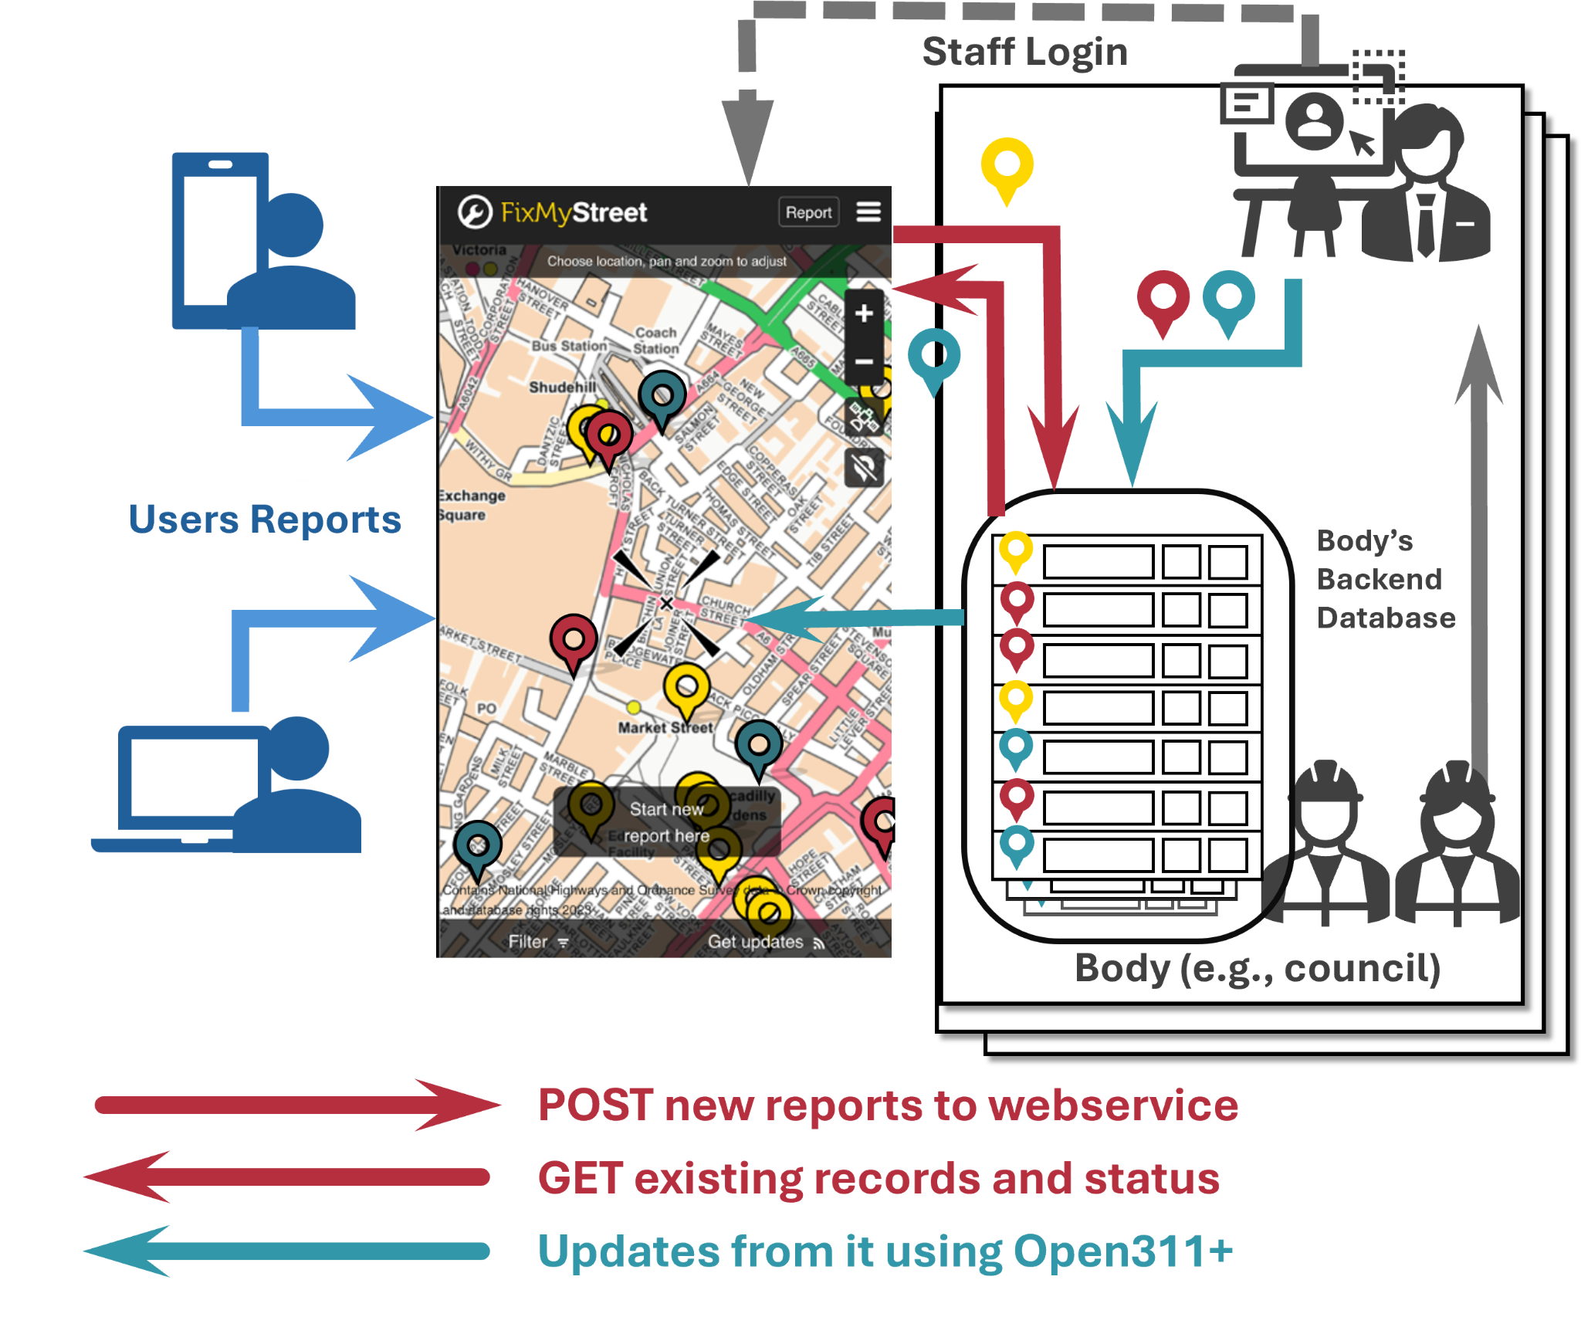**FixMyStreet Integration with Open311**

**Figure A1** illustrates how FixMyStreet (FMS) integrates the Open311 API at varying levels to streamline issue reporting between citizens and municipal authorities [[Link](https://fixmystreet.org/customising/integration/)].

| **User Interaction (No Integration)** |
| --- |
| At the most basic level, users submit civic issue reports via the FMS interface.  These are forwarded to authorities via email with no backend connectivity. |
| **Level 1 – Report Injection** |
| Using Open311's POST /requests endpoint, FMS sends structured reports directly to the authority's backend system. This eliminates manual data entry and allows authorities to assign internal reference IDs, which are then stored in FMS's system. |
| **Level 2 – Automatic Status Updates** |
| When a report is updated in the authority's backend, FMS polls for changes via GET /request_updates, reflecting the new status to the user without staff intervention. |
| **Level 3 – Backend-Originated Issues Displayed Publicly** |
| Issues created by municipal staff outside FMS can also be exposed on the platform through GET /requests, offering transparency into all ongoing work. |
| By adopting Open311, systems like FMS can achieve higher levels of automation, transparency, and scalability in issue resolution. Even if full integration is not possible now, it’s flexible, modular design allows progressive adoption to agency readiness. |

|  |
| --- |
| **Figure A1:** Level 3 Integration of the Open311 API Workflow |

|  |  |
| --- | --- |
| **GET Service Request (API)** | Query the current status of an individual request [[Link](https://wiki.open311.org/GeoReport_v2/#get-service-request)]. |

|  |  |  |  |
| --- | --- | --- | --- |
| **Purpose** | Query the current status of an individual request |  | [  {  "service_request_id":638344,  "status":"closed",  "status_notes":"Duplicate request.",  "service_name":"Sidewalk and Curb Issues",  "service_code":006,  "description":null,  "agency_responsible":null,  "service_notice":null,  "requested_datetime":"2010-04-14T06:37:38-08:00",  "updated_datetime":"2010-04-14T06:37:38-08:00",  "expected_datetime":"2010-04-15T06:37:38-08:00",  "address":"8TH AVE and JUDAH ST",  "address_id":545483,  "zipcode":94122,  "lat":37.762221815,  "long":-122.4651145,  "media_url":"http://city.sg/media/638344.jpg"  }  ] |
| **URL** | https://[API endpoint]/requests/[service_request_id].[format] |  |
| **Sample URL** | https://api.city.gov/dev/v2/requests/123.xm  ?jurisdiction_id=city.gov |  |
| **Formats** | XML (JSON available if denoted by Service Discovery) |  |
| **HTTP Method** | GET |  |
| **Requires API Key** | No |  |
| **Arguments** | service_request_id, jurisdiction_id* |  |
| **Figure A2:** GET Service API Overview | |  |
|  | |  | **Figure A3:** GET Service API Response Example |

|  |  |
| --- | --- |
| **Field Name** | **Description** |
| service_request_id | The unique ID of the service request created. |
| status | The current status of the service request. Accepts either "open" or "closed. |
| status_notes | Explanation of why status was changed to current state or more details on current status than conveyed with status alone. |
| service_name | The human readable name of the service request type |
| service_code | The unique identifier for the service request type |
| description | A full description of the request or report submitted.  May contain line breaks, but not code. Otherwise, this is free form text limited to 4,000 characters. |
| agency_responsible | The agency responsible for addressing the service request. |
| service_notice | Information about the action expected to fulfill the request. |
| requested_datetime | The date and time when the service request was made. Returned in w3 format, eg 2010-01-01T00:00:00Z |
| updated_datetime | The date and time when the service request was last modified. Returned in w3 format, eg 2010-01-01T00:00:00Z |
| expected_datetime | The date and time when the service request can be expected to be fulfilled. |
| address | Human readable address or description of location. |
| address_id | The internal address ID used by a jurisdictions master address repository or other addressing system. |
| zipcode | The postal code for the location of the service request. |
| lat | latitude using the (WGS84) projection. |
| long | longitude using the (WGS84) projection. |
| media_url | A URL to media associated with the request, eg an image. |
| **Figure A4:** GET Service API Response List | |

|  |  |
| --- | --- |
| **GET Service Type Request (API)** | Provides a list of acceptable 311 service request types [[Link](https://wiki.open311.org/GeoReport_v2/#get-service-list)]. |

|  |  |  |  |
| --- | --- | --- | --- |
| **Purpose** | Provide a list of acceptable 311 service request types and their associated service codes. These request types can be unique to the city/jurisdiction. |  | [  {  "service_code":001,  "service_name":"Cans left out 24x7",  "description":"Garbage or recycling cans that have been left out for more  than 24 hours. Violators will be cited.",  "metadata":true,  "type":"realtime",  "keywords":"lorem, ipsum, dolor",  "group":"sanitation"  },  ] |
| **URL** | https://[API endpoint]/services.[format] |  |
| **Sample URL** | https://api.city.gov/dev/v2/services.xml  ?jurisdiction_id=city.gov |  |
| **Formats** | XML (JSON available if denoted by Service Discovery) |  |
| **HTTP Method** | GET |  |
| **Arguments** | jurisdiction_id* |  |
| **Figure A5:** GET Service Type API Overview | |  | **Figure A6:** GET Service Type Response Example |

|  |  |
| --- | --- |
| **Field Name** | **Description** |
| service_code | id for the service request type |
| service_name | name of the service request type |
| description | A brief description of the service request type. |
| metadata | Determines whether there are additional form fields for this service type. |
| type | **realtime**: The service request ID will be returned immediately  **batch**: A token will be returned immediately, which can be later used to return the service request ID.  **blackbox**: No service request ID will be returned |
| keywords | A comma separated list of tags or keywords to help users identify the request type. |
| group | A category to group this service type within. |
| **Figure A7:** GET Service Type Response List | |

|  |  |
| --- | --- |
| **POST Service Request (API)** | Create service requests [[Link](https://wiki.open311.org/GeoReport_v2/#post-service-request)]. |

|  |  |  |  |  |
| --- | --- | --- | --- | --- |
| **Purpose** | Create service requests |  | **Field Name** | **Description** |
| **URL** | [https://API endpoint]/requests.[format] |  | service_request_id | The unique ID of the service request created. |
| **Sample URL** | https://api.city.gov/dev/v2/requests.xml |  | token | Use this to call GET service_request_id. |
| **Format Sent** | Content-Type: application/x-www-form-urlencoded |  | service_notice | Addressing the information reported. |
| **Formats** | XML (JSON available if denoted by Service Discovery) |  | account_id | The unique ID of the user reporting. |
| **HTTP Method** | POST |  | **Figure A9:** POST Service Response List | |
| **Requires API Key** | Yes |  |  |  |
| **Figure A8:** POST Service API Overview | |  |  |  |

|  |  |  |
| --- | --- | --- |
| **Field Name** | **Description** | **Required** |
| jurisdiction_id | This is only required if the endpoint serves multiple jurisdictions | Depends |
| service_code | This is obtained from GET Service List method | Yes |
| location parameter | A full location parameter must be submitted. | Yes |
| attribute | An array of key/value responses based on Service Definitions.  This is only required if the service_code requires a service definition with required fields`. | Yes |
| lat | Latitude using the (WGS84) projection. | No |
| long | Longitude using the (WGS84) projection. | No |
| address_string | Human entered address or description of the location.  This is required if no lat/long or address_id are provided. | Depends |
| address_id | The internal address ID used by a jurisdiction’s master address repository.  This is required if no lat/long or address_string are provided. | Depends |
| email | The email address of the person submitting the request | No |
| device_id | The unique device ID of the device submitting the request. This is usually only used for mobile devices. | No |
| account_id | The unique ID for the user account of the person submitting the request | No |
| first_name | The given name of the person submitting the request | No |
| last_name | The family name of the person submitting the request | No |
| phone | The phone number of the person submitting the request | No |
| description | A full description of the request or report being submitted.  This may contain line breaks, but not html or code. Otherwise, this is free form text limited to 4,000 characters. | No |
| media_url | A URL to media associated with the request, eg an image. | No |
| **Figure A10:** POST Service Arguments | | |

# **APPENDIX B:** Leveraging OpenStreetMap

OpenStreetMap (OSM) is a global open-source mapping platform that offers editable geographic data contributed by volunteers.   
For our project, it plays a pivotal role in spatial analysis, urban issue localisation, and custom geovisualization—all while avoiding the licensing restrictions of commercial maps. The Learn OSM website provides easy to understand, step-by-step guides to get started with OSM [[Link](https://learnosm.org/en/)].

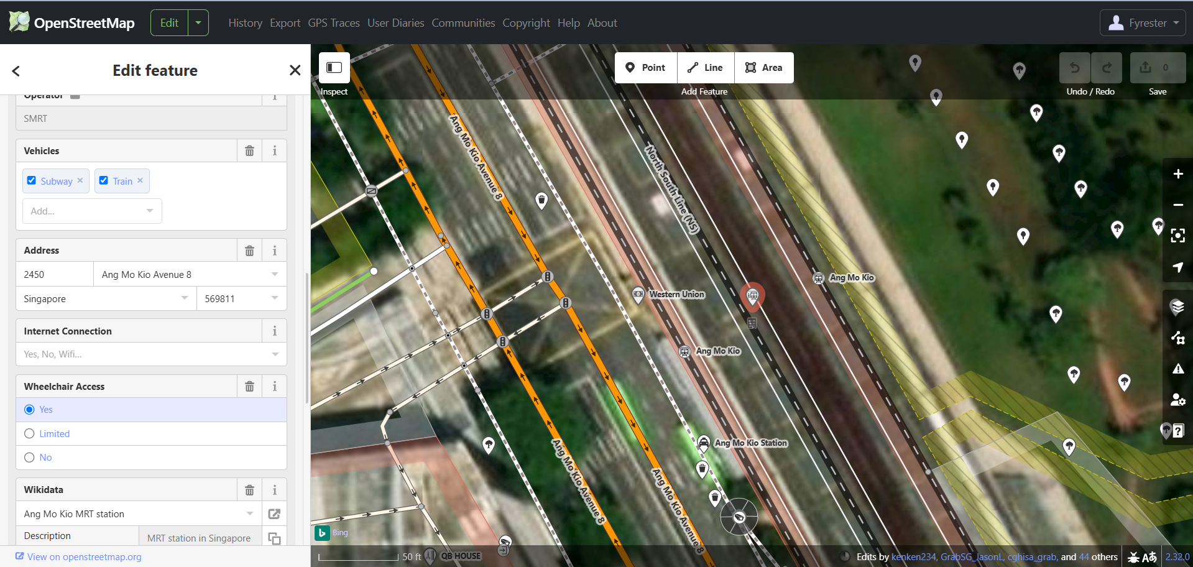**OSM as a Geospatial Layer**

OSM provides access to detailed data such as:

|  |  |  |
| --- | --- | --- |
|  | ■ | Road Networks |
|  | ■ | Building Footprints |
|  | ■ | Public Infrastructure (e.g. Parks, Streetlights, Bins) |
|  | ■ | Geographical Regions |
|  | By overlaying reported issues on these layers, we may  be able to include these into our model analysis: | |
|  | ■ | Perform spatial clustering of faults  (e.g., potholes concentrated in older estates) |
|  | ■ | Estimate risk zones based on  environmental and infrastructural factors |
|  | ■ | Correlate issue types with nearby POIs  (e.g., illegal dumping near public bins) |

**Figure B1:** OSM Default On-line Editor

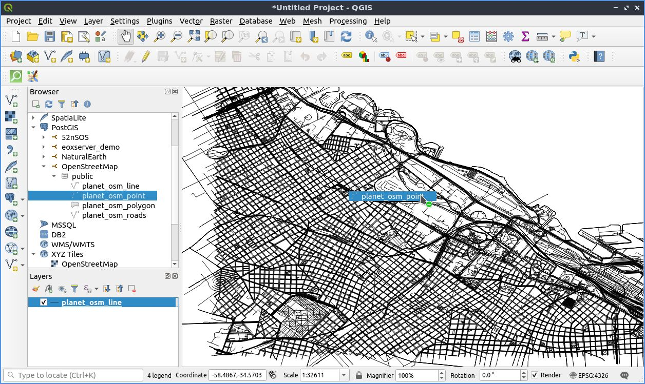**OSM Editing Software**  
There are various software — online and offline, which can be used to edit and render OSM data, such as:

| **iD** | The default on-line editor. It's easy to use, and allows mapping from various data sources. |
| --- | --- |
| **JOSM** | An advanced editor, written in Java. Can be used for bulk editing, and extended via plugins. |
| **QGIS** | OSM data can be loaded in QGIS as a vector layer, a core functionality or through plugins. |
| **Osmosis** | A utility program for performing many tasks at a raw level on OSM data, which includes ETL. |
| **osm2pgsql** | A utility program that converts .osm data into PostgreSQL, often used to render via Mapnik |
|  |  |

We can use these software to:

|  |  |
| --- | --- |
| ■ | Tag specific structures (e.g., "damaged sidewalk") |
| ■ | Validate automated geotagging from user reports |
| ■ | Update underlying OSM data where necessary |

**Figure B2:** Editing & Customizing with OSM QGIS Software

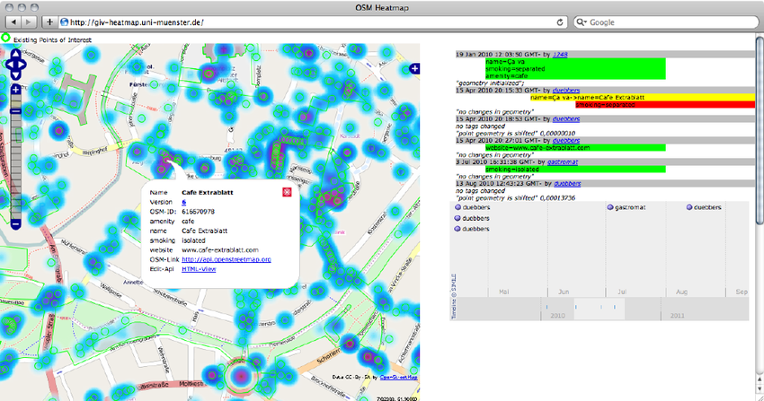**Integrating OSM**  
While integrating OSM data is a new frontier for us, we see it as a valuable opportunity to enhance our spatial analysis. In our implementation, this would involve:

|  |  |  |
| --- | --- | --- |
|  | ■ | Road Networks |
|  | ■ | Building Footprints |
|  | ■ | Public Infrastructure (e.g. Parks, Streetlights, Bins) |
|  | ■ | Geographical Regions |
|  | By overlaying reported issues on these layers, we may be able to include these into our model analysis: | |
|  | ■ | Perform spatial clustering of faults  (e.g., potholes concentrated in older estates) |
|  | ■ | Estimate risk zones based on  environmental and infrastructural factors |
|  | ■ | Correlate issue types with nearby POIs  (e.g., illegal dumping near public bins) |

**Figure B3:** Heat Map Generated with OSM

# **APPENDIX C:** Application Interface

|  |  |  |  |
| --- | --- | --- | --- |
| **Figure C1:** Chatbot Options | **Figure C2:** Chatbot calling CV model | **Figure C3:** Chatbot manual correction | **Figure C4:** Chatbot raising ticket |

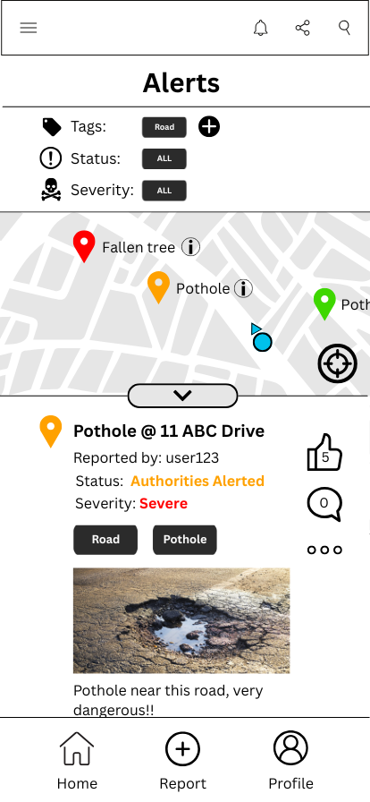

The above images illustrate how a user can report an issue via chatbot interaction.

While a manual form—similar to OneService—will be available, some users may prefer a conversational assistant for a more guided and convenient reporting experience.

**Figure C1** shows the chatbot’s main options, namely:

|  |  |
| --- | --- |
| ( 1 ) | Report an issue through chat interaction. |
| ( 2 ) | Check the status of previous reports, with the option to revoke any reports. |
| ( 3 ) | View nearby conditions, as well as manage notification settings. |
| ( 4 ) | Ask municipal-related questions. |

**Figure C2** presents a sample conversation for reporting an issue.

Upon sending an image (when asked), it triggers the backend services to automatically detect the Issue Type, Severity Level, Municipal Agency, Tags and Location, which then gets filled for the user to view.

**Figure C3** continues the interaction.

While fields are auto-filled, users may still edit or add information before submission.

**Figure C4** shows the final confirmation.

Once the user verifies the details, the chatbot files the report.

By selecting "View Ticket", users can track the status and queue number.

**Figure C5** displays a possible preview of the live geographical map interface.

Each raised and acknowledged ticket appears here with icons representing issue types.

A filter system will be located at the top to allow users to toggle issues by their Tags, Status and Severity.

Clicking on a specific icon opens the forum post related to that issue. Users who choose not to share it publicly will not have their name displayed, and no commenting system will be displayed either.

|  |
| --- |
| **Figure C5:** Live Geographical Map |